### **Day 15**

### **Project Problem Statement**

A development team needs to establish a basic CI/CD pipeline for a web application. The goal is to automate version control, containerization, building, testing, and deployment processes.

### **Deliverables**

1. **Git Repository:**
   * **Create a Git repository**: Initialize a new repository for the web application.
   * **Branching Strategy**:
     + Set up main and develop branches.

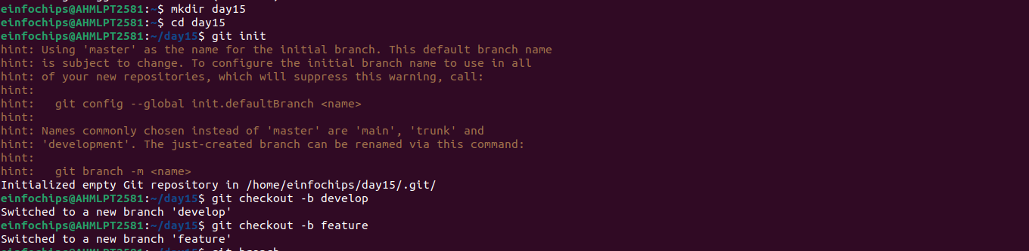

* + - Create a feature branch for a new feature or bug fix.
  + **Add Configuration Files**:
    - Create a .gitignore file to exclude files like logs, temporary files, etc.

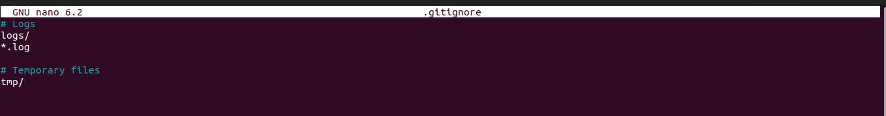

* + - Create a README.md file with a project description, setup instructions, and contribution guidelines.

1. **Docker Configuration:**
   * **Dockerfile**:
     + Write a Dockerfile to define how to build the Docker image for the web application.

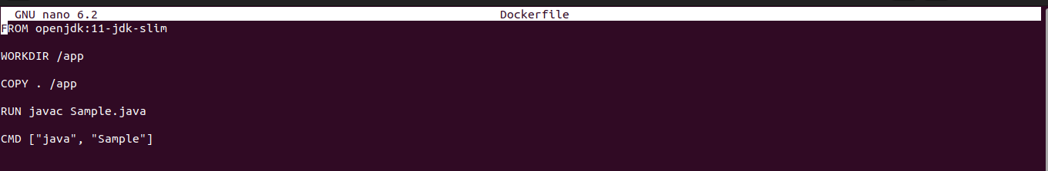

* + **Docker Ignore File**:
    - Create a .dockerignore file to exclude files and directories from the Docker build context.
  + **Image Management**:
    - Build a Docker image using the Dockerfile.
    - Push the built Docker image to a container registry (e.g., Docker Hub).

1. **Jenkins Configuration:**
   * **Jenkins Job Setup**:
     + Create a Jenkins job to pull code from the Git repository.

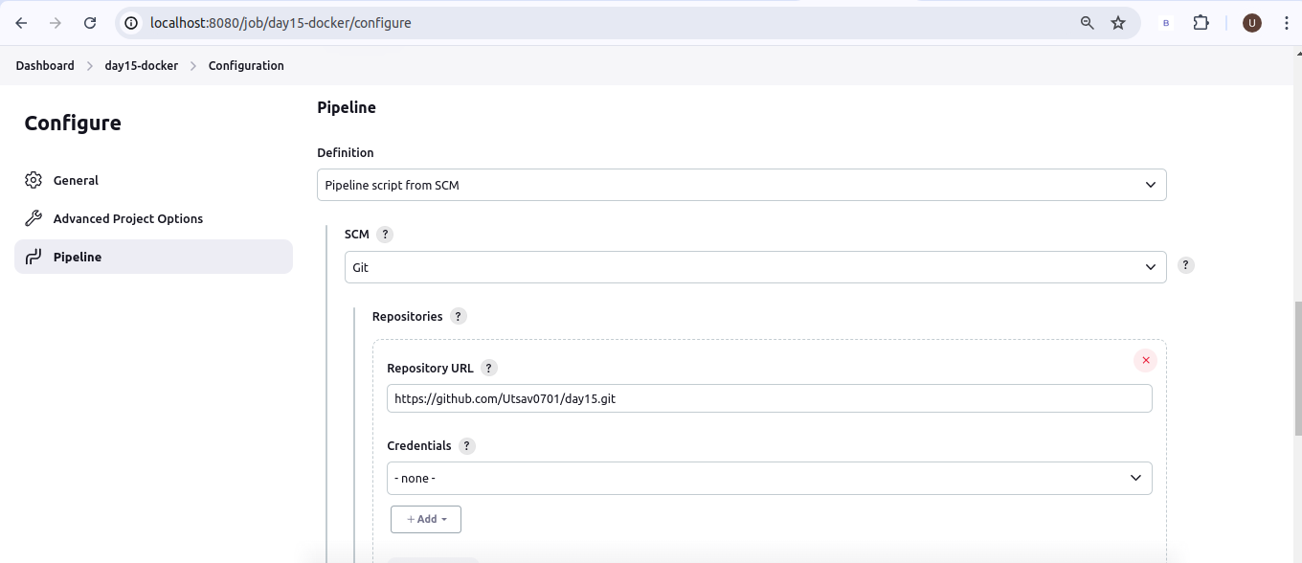

* + - Configure Jenkins to build the Docker image using the Dockerfile.

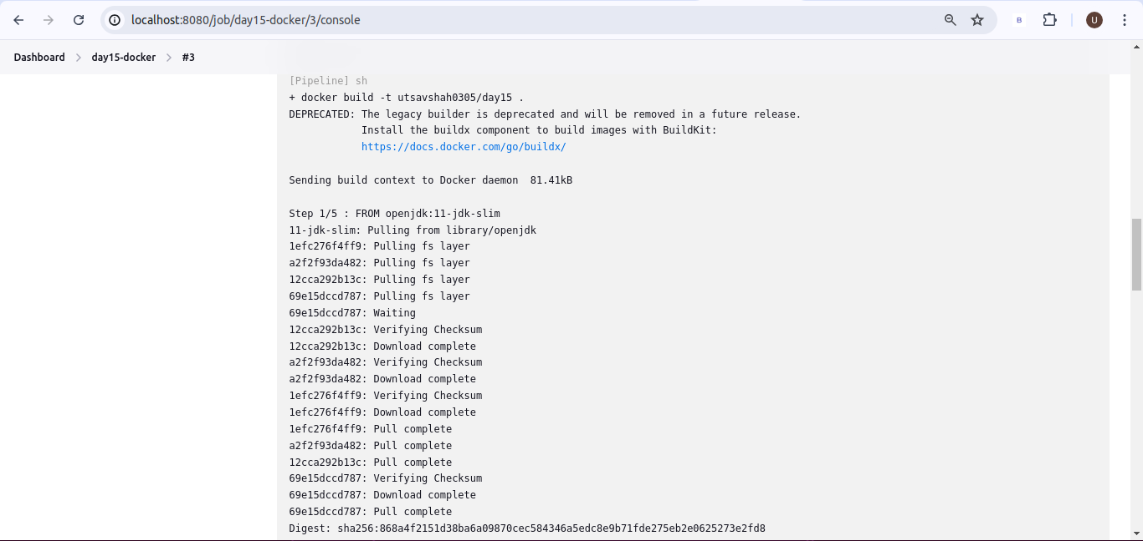.

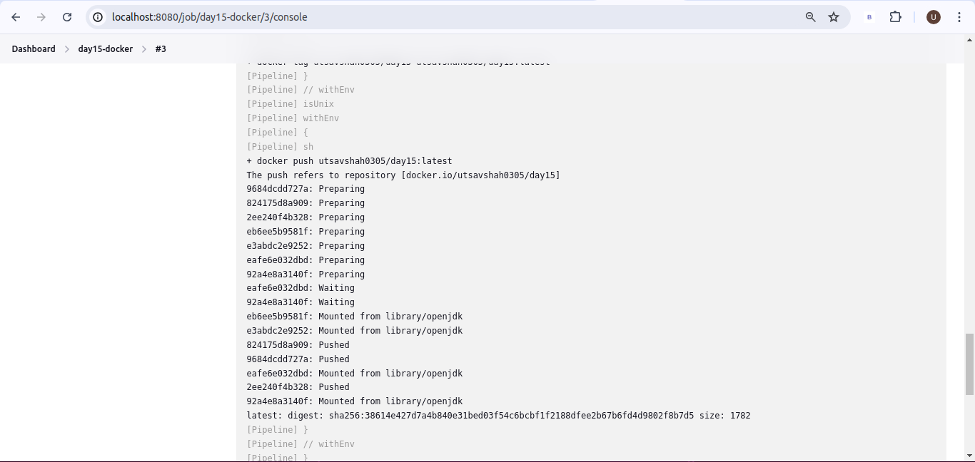.

* + - Set up Jenkins to run tests on the Docker image.
    - Configure Jenkins to push the Docker image to the container registry after a successful build.
  + **Jenkins Pipeline**:
    - Create a Jenkinsfile to define the CI/CD pipeline stages, including build, test, and deploy.

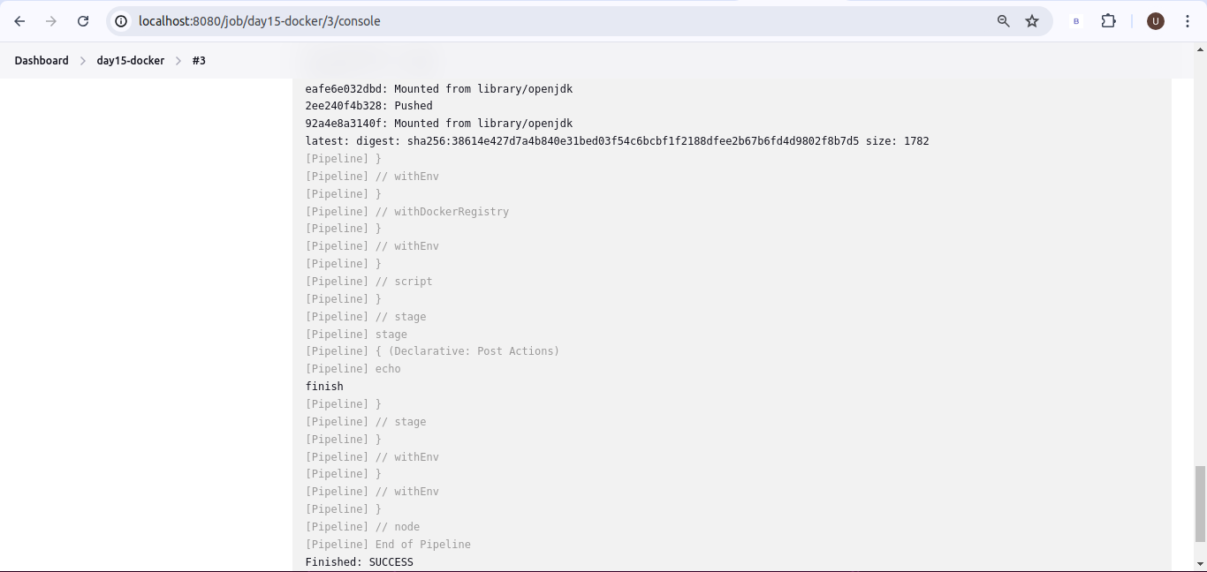

1. **Ansible Playbook:**
   * **Basic Playbook Creation**:
     + Develop an Ansible playbook to automate the deployment of the Docker container.
   * **Playbook Tasks**:
     + Install Docker on the target server (if Docker is not already installed).
     + Pull the Docker image from the container registry.
     + Run the Docker container with the required configurations.
   * **Inventory File**:
     + Create an inventory file specifying the target server(s) for deployment.

